LIBRARY

1. Create a keyspace by name Library.

CREATE KEYSPACE library WITH REPLICATION={ 'class' : 'SimpleStrategy',
'replication_factor' : 1};
USE library;

2. Create a column family by name Library-Info with attributes
Stud_Id Primary Key,
Counter_value of type Counter,
Stud_Name, Book-Name, Book-Id, Date_of_issue

create table library_info(stud_id int, counter_value Counter, stud_name
text,book_name text, date_of_issue timestamp, book_id int, PRIMARY
KEY(stud_id,stud_name,book_name,date_of_issue,book_id));

3. Insert the values into the table in batch.

UPDATE library_info SET counter_value = counter_value + 1 WHERE stud_id
= 111 and stud_name = 'SAM' and book_name = 'ML' and date_of_issue =
'2020-10-11'and book_id = 200;
UPDATE library_info SET counter_value = counter_value + 1 WHERE stud_id
= 112 and stud_name = 'SHAAN' and book_name = 'BDA' and date_of_issue =
'2020-09-21'and book_id = 300;
UPDATE library_info SET counter_value = counter_value + 1 WHERE
stud_id = 113 and stud_name = 'AYMAN' and book_name = 'OOMD' and
date_of_issue = '2020-04-01'and book_id = 400;
SELECT * FROM library_info;

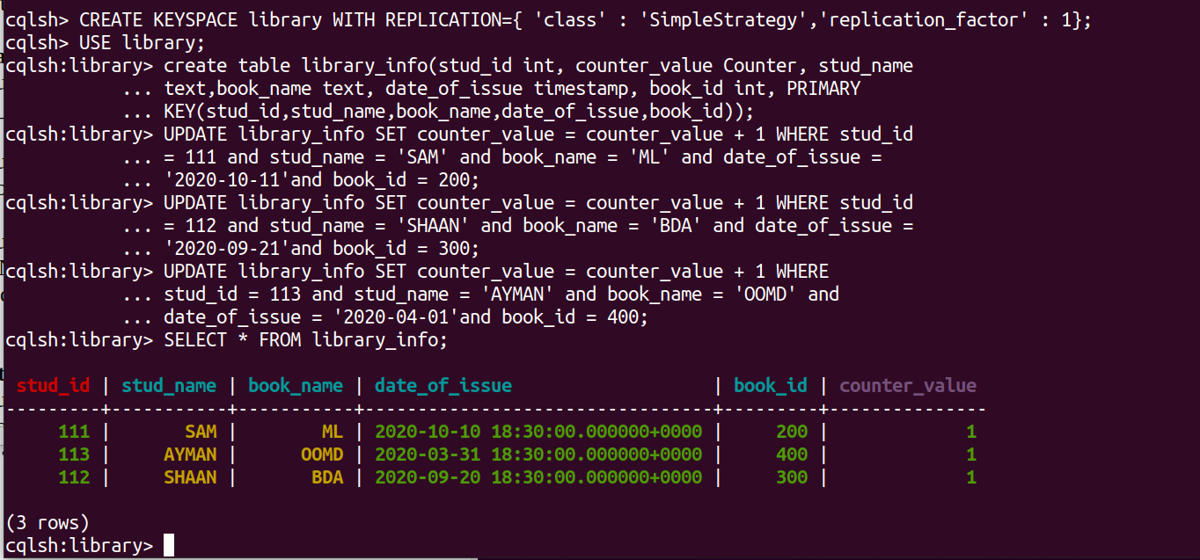

4. Display the details of the table created and increase the value of the counter.

UPDATE library_info SET counter_value = counter_value + 1 WHERE stud_id
= 112 and stud_name = 'SHAAN' and book_name = 'BDA' and date_of_issue =
'2020-09-21'and book_id = 300;

5. Write a query to show that a student with id 112 has taken a book “BDA” 2
times.

SELECT * FROM library_info WHERE stud_id = 112;

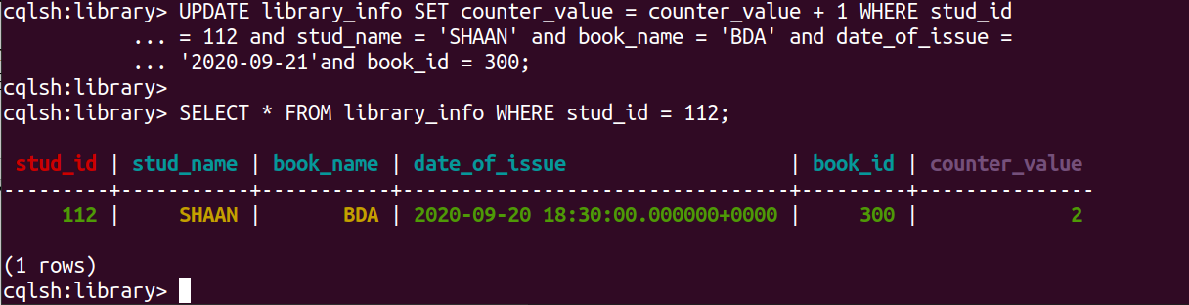

6. Export the created column to a csv file.

COPY Library_Info (Stud_Id, Stud_Name, Book_Name, Book_Id, Date_Of_Issue, Counter_value) TO '/home/sahana/Desktop/library_info.csv';

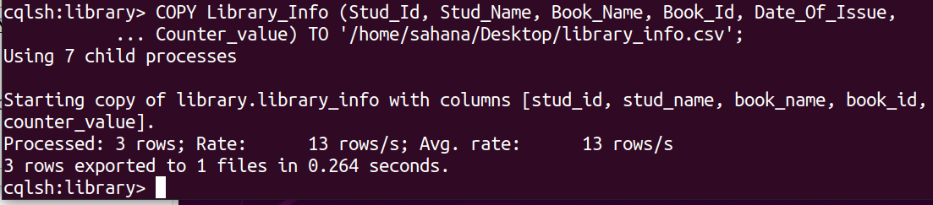

7. Import a given csv dataset from local file system into Cassandra column
family.

create table library_info2(stud_id int, counter_value Counter, stud_name
text,book_name text, date_of_issue timestamp, book_id int, PRIMARY
KEY(stud_id,stud_name,book_name,date_of_issue,book_id));
COPY library_info2 (stud_id, stud_name, book_name, book_id, date_of_issue, counter_value) FROM '/home/sahana/Desktop/library_info.csv';

SELECT * FROM library_info2;

